0P `1

**Principal's Corner**

Greetings Roosevelt Families,

We have sold out our FUNdraiser tonight and greatly appreciate the support from staff and families. We are beginning our MCAS season of testing in April. Our students have been well prepared through rigorous instruction all year long. We are fortunate to have the technology to allow the testing on-line too. Thank you to the Middle School Student Council members who have created MCAS survivor bags for all testing students! I have started a new communication called Roosevelt Happenings that will be emailed out several times a month. I hope you enjoy getting the updates of Roosevelt events and activities! Stay tuned.

https://ssl.gstatic.com/ui/v1/icons/mail/images/cleardot.gif

**Revised Calendar for the 2016 - 2017 School Year**

Please review the updated calendar for the 2016 - 2017 school year. Due to snow day school cancellations, the last day of school is now June 28th. The full calendar and details can be found on the District homepage. Please check the website for further information:www.bostonpublicschools.org/Roosevelt

https://ssl.gstatic.com/ui/v1/icons/mail/images/cleardot.gif

**April 3**

**MCAS Gr.5 & 8 ELA**

**April 4**

**MCAS Gr 5 & 8 ELA**

**April 5**

**MCAS GR.5 ELA**

**April 6**

**ELA. Gr. 7**

**April 7**

**MCAs Gr 7 ELA**

**April 10**

**MCAS Gr. 3 & 6 ELA**

**April 11**

**MCAS Gr. 3&6 ELA**

**April 12**

**ELA Gr 3**

**April 14**

**No School**

**Vacation Begins**

**Students Return to School**

**April 25**

**April 25,26 &27**

**MCAS Gr.4 ELA**

**April 25 & 26**

**Gr. 7 Math**

**May 1 & 2**

**Gr. 8 Math**

**N**

**Big Time News**

**Roosevelt School**

**April 1, 2017**

Big Time News – November 1, 2016

**Upper Campus**

Congratulations to the following students in grades 2-5 who received recognition for being responsible core and scholars!

|  |  |  |
| --- | --- | --- |
| **Class** | **Core Value Recipient**  **March** | **Scholar Recipient**  **March** |
| 101 | Brianna C. | Alessandra P. |
| 102 | Bryan AP. | Deanny M. |
| 103 | Elias V.  Diego S. | Mark J. |
| 104 | Xavier B. | David W.  Alex R. |
| 201 | Adrieanna | Math Maria T. |
| 202 | Miguel O. | Math Joseph J. |
| 203 | Jacinth J. | Javen G. |
| 204 | Rebecca K. | Mary L. |
|  |  |  |
|  |  |  |

**Core Value for April Creativity**

The use of the imagination or original ideas, especially in the production of an artistic work.

|  |  |
| --- | --- |
| *synonyms:* | [inventiveness](https://www.google.com/search?safe=strict&biw=1440&bih=770&q=define+inventiveness&forcedict=inventiveness&sa=X&ved=0ahUKEwiHheHTourSAhXHwFQKHcLEDCcQ_SoIGzAA), [imagination](https://www.google.com/search?safe=strict&biw=1440&bih=770&q=define+imagination&forcedict=imagination&sa=X&ved=0ahUKEwiHheHTourSAhXHwFQKHcLEDCcQ_SoIHDAA), [innovation](https://www.google.com/search?safe=strict&biw=1440&bih=770&q=define+innovation&forcedict=innovation&sa=X&ved=0ahUKEwiHheHTourSAhXHwFQKHcLEDCcQ_SoIHTAA), ess, [originality](https://www.google.com/search?safe=strict&biw=1440&bih=770&q=define+originality&forcedict=originality&sa=X&ved=0ahUKEwjLxIOTo-rSAhUJ0GMKHShIBr8Q_SoIHjAA), [individuality](https://www.google.com/search?safe=strict&biw=1440&bih=770&q=define+individuality&forcedict=individuality&sa=X&ved=0ahUKEwjLxIOTo-rSAhUJ0GMKHShIBr8Q_SoIHzAA) |

Innovativeness, [originality](https://www.google.com/search?safe=strict&biw=1440&bih=770&q=define+originality&forcedict=originality&sa=X&ved=0ahUKEwjLxIOTo-rSAhUJ0GMKHShIBr8Q_SoIHjAA), [individuality](https://www.google.com/search?safe=strict&biw=1440&bih=770&q=define+individuality&forcedict=individuality&sa=X&ved=0ahUKEwjLxIOTo-rSAhUJ0GMKHShIBr8Q_SoIHzAA)

**K2 Classroom News**

K2 has just started a new unit called "Construction" .  The children are learning about how structures are built and are becoming familiar with the engineering process.  They are completing various construction challenges which allow them to learn about what makes a structure stable.  In Math, we started a unit that involves measuring and finding the length of various objects.  We are learning to compare the size of objects and determine which object is longer.

We are also pleased that some of our families have taken advantage of the "Boston Saves" program being offered to K2 families that allows them to earn free money for saving towards their child's future.  If you are a K2 family who has not taken advantage of this program yet, please touch base with your child's teacher and they can help you get started!

**Grade 8 Math News**

It is a very exciting time of the year in the 8th grade, as many of our students are being sent their acceptance letters for High School placements for next fall!  We are very proud of this year’s class as they have been accepted to a variety of schools, including such places as the Boston Arts Academy, Charlestown High School, the Edward M. Kennedy School, and Fenway High School.  An even more impressive stat is that 26% of our 8th graders will be attending one of Boston’s Exam Schools, including the John D. O’Bryant, Boston Latin Academy, and Boston Latin School!  Way to go 8th graders!!!

# 

**Franklin D. Roosevelt School**

**Principal Lynda-Lee Sheridan**

**Assistant Principal Bannet Steele**

**Upper Campus**: 95 Needham Road, Hyde Park, MA 02136

P: 617-635-8676

F: 617-635-8679

**Lower Campus**: 30 Millstone Road, Hyde Park, MA 02136

P: 617-635-9280

F: 617-635-9284

Please visit our website at **bostonpublicschools.org/Roosevelt**

to find all general information about the school and classroom web pages. You can also stay informed through **Twitter @RooseveltK8BPS**

**FDR Drama Club**

We are very proud of all the students who participated in Charlotte’s Web! Thirty students in grades two through eight participated in the full-length production, performing on stage or working backstage with props and sets. This is the third large-scale production for the Roosevelt and it is amazing to see the students grow as actors throughout these productions. It is very inspiring to see the level of camaraderie, cooperation and support that all cast members shared. It is a testament to the power of the arts and why it is essential in our schools.

Our lower campus students recently presented a performance of “The Story of Ferdinand” by Munro Leaf for families too! We are incredibly proud of all twenty students who worked hard for eight weeks to put together this performance.

**Rock your Socks**

On March 21st, many members of the Roosevelt Community rocked their socks for World Down Syndrome Day (WDSD).  WDSD raises awareness and serves as a reminder of the abilities individuals with Down Syndrome have and the important roles individuals with DS play in our communities.

On WDSD, we saw knee socks, colorful socks, mismatched socks, toes socks and no socks. 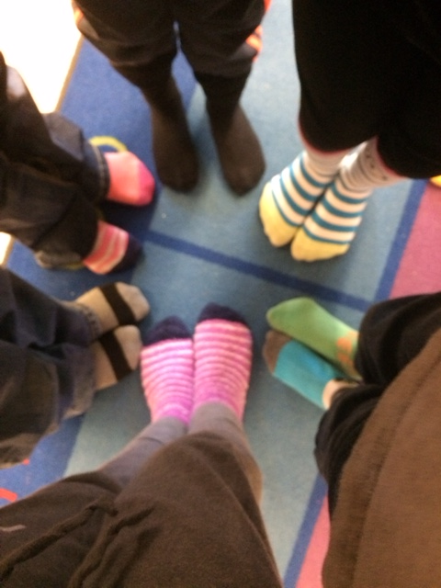

**Grade 6 – 8 Science**

Middle school science classes just began their third and final unit for the year.  Seventh grade is beginning "Diversity of Life," our life science unit for the year.  Eighth grade is beginning "Chemical Interactions," our chemistry unit for the year.  Mark your calendars because eighth grade MCAS is May 17 and 18.  Ms. Nissley has free outdoor summer camp opportunities for current sixth and seventh graders at Thompson Island.  Please speak to me if you're interested.

**Lower Campus**

**Core Value and Scholar Award Recipients**

Congratulation to our students in K)?K!, K2 and 1st

Gr.who were recently awarded the cvore and Scholar awards for March.

**Core**  Purple room Jeremiah, Blue rm. Lulu,Yellow rm. Alvin, Red rm. Robert, Green rm. Chrissy, Orange Leif

**Scholar** Purple rm. Jaelin, Blue rm. Johnny, Jason & David, Red rm. Allen, Green rm. Dayla, Orange rm. Jabrie

**Stay Tuned and Save the Date!**

The Lower Campus Wellness Council will have what we hope will be an annual Lower Campus Healthy Family Fun Night on June 6th. Thanks to the initiative and leadership of Nurse Carline Louis-Letang and Mrs. Faldasz, we have started the ball rolling! There will be lots of activities to keep families moving and learning all about healthy living. There will be more news to come.

**SPC Corner**

Next SPC meeting will be held on April 13th at 6pm at the Upper Campus. Come hear Mrs. Sheridan speak about the Extended Learning Time for next school year!  Refreshments will be served and child care is available ONLY by contacting Pam ([blish3939@hotmail.com](mailto:blish3939@hotmail.com)) or Tracy ([tracy7775@msn.com](mailto:tracy7775@msn.com)) ahead of time.  All who attend will be entered into a raffle.  Also at this meeting we will be recruiting helpers for planning Field day.  If you are interested in helping to plan, please come out to this SPC Meeting.

The SPC will be sponsoring a FAMILY GAME NIGHT on Thursday May 4th from 530-730pm.  Pizza and beverages will be provided.  Please bring a snack or dessert to share!!!

Coming Soon:  Little Free Library Dedication at the Lower Campus.  Be on the lookout for the date and time!!!

Also the Winners of the Candy sale will be announced soon!!! Thank you to everyone who helped out by selling, buying and filling candy orders.

**Save the date:**  
**FIELD DAY Lower - June 2nd; Upper - June 9th. We will be looking for volunteers!**  
Any questions, ideas or comments, please contact Pam Bellamy @ [blish3939@hotmail.com](mailto:blish3939@hotmail.com) or Tracy @ [tracy7775@msn.com](mailto:tracy7775@msn.com).

**Lower Campus Happenings**

The hop-a-thon is this Friday.  Here is some info about the hop-a-thon.  Let me know if you have any questions or concerns.

➢ The hop-a-thon will take place in the gym.

➢ There will be 6 hopping stations and kids will rotate through them as a group. Each class will come down as a whole class.  There will be hopping stations (I will give you a list a few days before the hop-a-thon).

➢ So far we have a few parents volunteering for taking a group and with your help (teachers and paras), we have enough adults for the groups.  We are hoping to get a few more volunteers.  Each adult will guide the group through the station and record the number of hope on a list on a clipboard (I will have these ready that morning.)

➢ A sheet will be sent home with the kids that day to let their families know how many times they hopped/jumped.

**Girl Scouts**

The Lower Campus Girl Scouts recently braved freezing temperatures to bring more than 75 boxes of donated cookies to Hanscom Air Force Base.  These cookies will be sent to members of the military serving overseas. The girls met and spoke with active members of the military and made thank you cards that will be sent with their cookies overseas.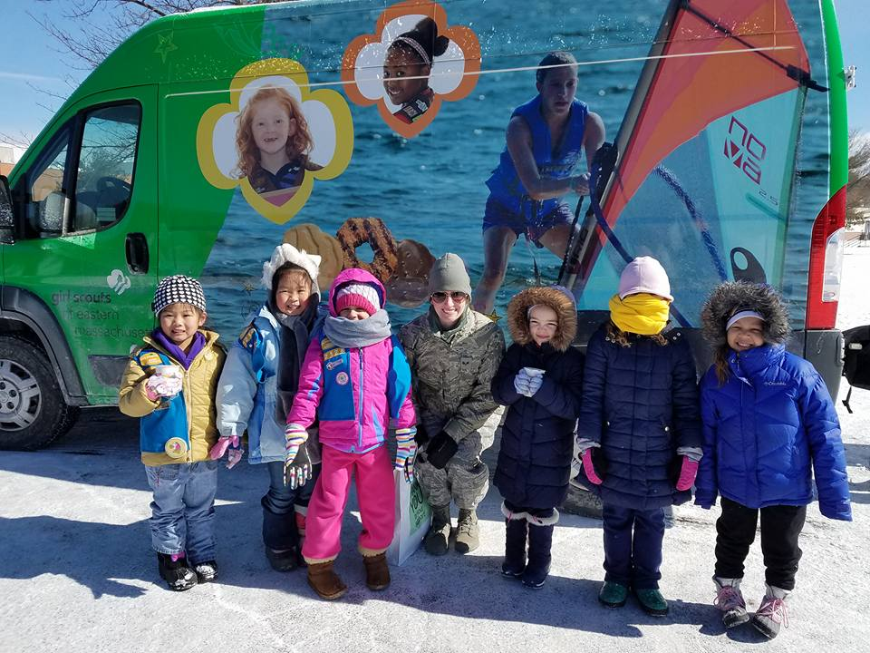ies.

**Girls Basketball**

The girls’ basketball team finished the regular season undefeated with a record of 8-0.  The first playoff game will be next Tuesday (April 4th) at the Shelburne Community Center at 4:30pm.

Please come and show your support